Major Project Synopsis
On
NFTMARKET

For the partial fulfillment for the award of the degree of

Bachelor of Technology
In

Computer Science and Engineering

Submitted By

Divisha Roy (1905110100047)
Alwin Jacob (190151101100015)

Under the supervision of
Mr. Shivam Tiwari



G.L. BAJAJ GROUP OF INSTITUTIONS, MATHURA

Affiliated to

DR. APJ ABDUL KALAM TECHNICAL UNIVERSITY,

2022-2023

- Introduction

What is NFTs?
NFT stands for non-fungible token. An NFT is a digital asset that represents real-world objects like art, music, in-game items and videos. They are bought and sold online, frequently with cryptocurrency, and they are generally encoded with the same underlying software as many cryptos.
Although they’ve been around since 2014, NFTs are gaining notoriety now because they are becoming an increasingly popular way to buy and sell digital artwork. NFTs are also generally one of a kind, or at least one of a very limited run, and have unique identifying codes.

What is NFTMarket?
Online marketplaces for digital assets are the recent talk of the fintech town. NFT marketplace is such a marketplace that functions as a public website.
It is a platform that makes it simple to store and sell NFTs. These tokens are generally available for purchase or auction at a set price. To use an NFT marketplace, you will need a wallet to store and trade your best NFT tokens.
This marketplace is like an e-Commerce platform, say Amazon or eBay where different products are listed by sellers, and buyers can buy them.
In this, users have to create an account, upload digital artworks, and sell their work on the marketplace. In general, specialized marketplaces are more popular than conventional ones because they include everything a client would require—specialized marketplaces expertise in promoting online artworks and concentrating on specific target audiences.

- Objectives

The platform provides the user to buy and sell unique NFTs.

- Existing System (for utility/application/Regular-based project / (Related work (for research /patent related project)

A specialized marketplace for NFT buying, selling and trading didn’t exist initially after these unique digital tokens entered the mainstream. OpenSea's creation was the first of its kind. It’s frequently compared to eBay when conveying its workings to beginners. This comparison is apt, since OpenSea essentially operates like eBay, Etsy or any other well-known buying/selling platform. The only difference is this site transacts exclusively with digital items -NFTs. You can use OpenSea’s platform to set fees on your tokens, and to create custom marketplaces for NFT art projects and auctions for selling them.
As OpenSea’s marketplace is noncustodial, the transactions made on the platform are facilitated by self-executing smart contracts. This means that fair trade is guaranteed. Transactions for both buyer and seller achieve win-win situations — or the parties don’t transact at all.
- Motivation(forutility/application/Regular-based project)/Problem Statement (For research/patent related project)

- For content creators, it’s a unique opportunity to monetize their wares. For example, artists no longer have to rely on galleries or auction houses to sell their art. Instead, the artist can sell it directly to the consumer as an NFT, which also lets them keep more of the profits. In addition, artists can program in royalties so they’ll receive a percentage of sales whenever their art is sold to a new owner. This is an attractive feature as artists generally do not receive future proceeds after their art is first sold.
- Art isn’t the only way to make money with NFTs. Brands like Charmin and Taco Bell have auctioned off themed NFT art to raise funds for charity. Charmin dubbed its offering “NFTP” (non-fungible toilet paper), and Taco Bell’s NFT art sold out in minutes, with the highest bids.
- Digital artists, who regard the emergence of NFTs as something godsend, believe that OpenSea does not go far enough in preventing copying and unethical conduct. @NFTTheft, a Twitter account dedicated to uncovering plagiarism on OpenSea. The verdict was changed within 24 hours due to public outrage. In a backpedalling Twitter thread, OpenSea claimed that more than 80% of NFTs created in this manner contained “plagiarised works, fraudulent collections, and spam.”

- Methodology (for utility/application/Regular-based project/Proposed Method (Research/patent based)

The site begins with the Register/login page if the user is new then he will be redirected to the register page and if not then to the login page. After Registration/Login the home page comes with information about the site and what it does and includes samples of NFT images. Then it has a navbar which includes various sections like Profile section, NFT upload/Buy section, view top or best selling NFT’s and many more. NFT’s upload/Buy section includes uploading of new NFT you want to sell, and in the Buy section owner of the NFT can put a fixed price for that NFT or users can offer the price near or above the owner’s price and the user who given the higher price will be granted the access to buy that NFT from the owner. On Clicking Buy users will be redirected to the payment section where its digital wallet metamask is used.
While Uploading a new NFT’s on this site it will match the new NFT with it’s already uploaded NFT’s on site database and if this NFT get matched with any of the NFT’s then a reminder message will be sent to the original owner of the NFT, and that owner can perform action and will be able to stop the user from uploading, If the new NFT doesn’t match with anyone of the previous NFT’s then the user is clear to upload that NFT and will be able to sell it.

- Plan of work

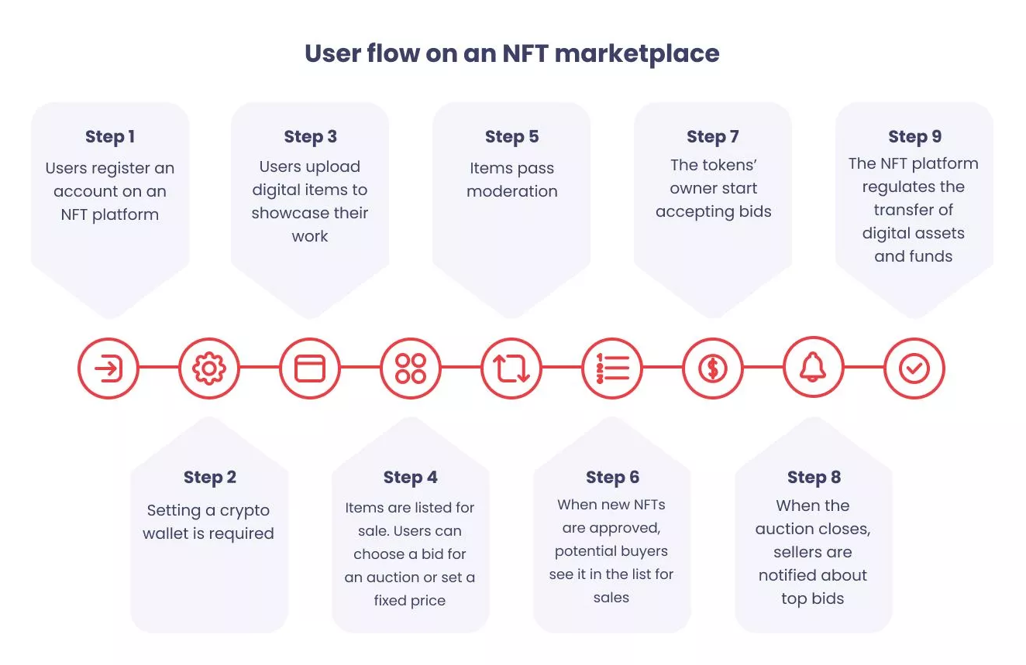
.

- Tools and Technology used/Hardware/Software Requirements

- Processor: Intel Core i7
- 4 GB RAM (Minimum)
- Operating System Windows(Windows 10 pro)
- Software Application: V.S code
- Tech Stack:
Front-End technologies
- HTML5
- CSS3
- JAVASCRIPT
Back-End technologies
- Node js
- Express js
- SQL
- Rest API
For Plagiarism
- Python Language
- ML Algorithms

- Reference

- https://opensea.io/
- https://www.nftically.com/
- https://www.w3schools.com/css/
- https://www.w3schools.com/html/
- https://www.w3schools.com/js/
- https://getbootstrap.com/docs/5.2/getting-started/introduction/

